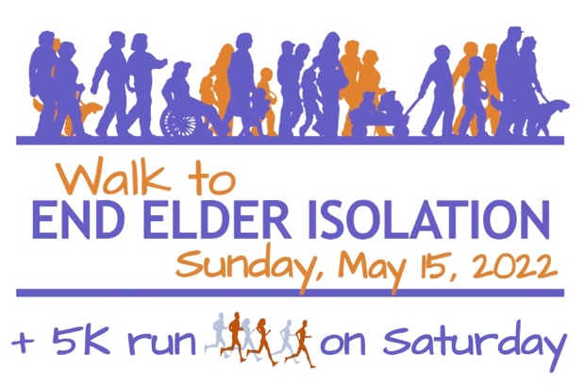

HOW TO GET THERE:
DRIVING AND PARKING

The address for Rogerson House is 434 Jamaicaway, but for GPS purposes and public transportation, use 32 Beaufort Road, Jamaica Plain. Rogerson House is located at the end of Beaufort Road.

There is NO PARKING at Rogerson House! You can drop someone off if they cannot walk the 4 blocks, but you must then move your car. Park on Centre Street or the side streets if you can find a non-residential space, or park in the Curley School lots at 40 Pershing Road just 4 blocks away (see map below); we have permission from the principal!

